FRIDAY WE STRIKE
In solidarity with the global #FridaysForFuture movement you are invited to join us to demand justice for the planet. We will leave during callback (with parent’s permission to sign out) and walk to the State House to join Montpelier High School’s strike.
For more information contact kmartzke20@wcsu32.org
How can I do this without getting in trouble?
With your parents permission! Have them write a note or call/email the school informing them you will be leaving school early for the strike!
How will I get a ride back to school?
Carpooling back to school is being organized. Email me or come to the callback on Tuesday in room 126 for more info.
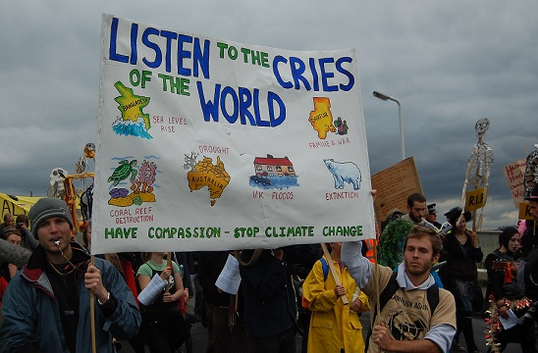
Why are we striking?
We are striking to take a stand against climate change. As the student who started this movement, Greta Thunberg, words it,
“Why study for a future which may not be there?
Why spend a lot of effort to become educated when our governments are not listening to the educated?”
We are asking you to strike for the cause of saving the world.

